小高层楼栋物品清理公告

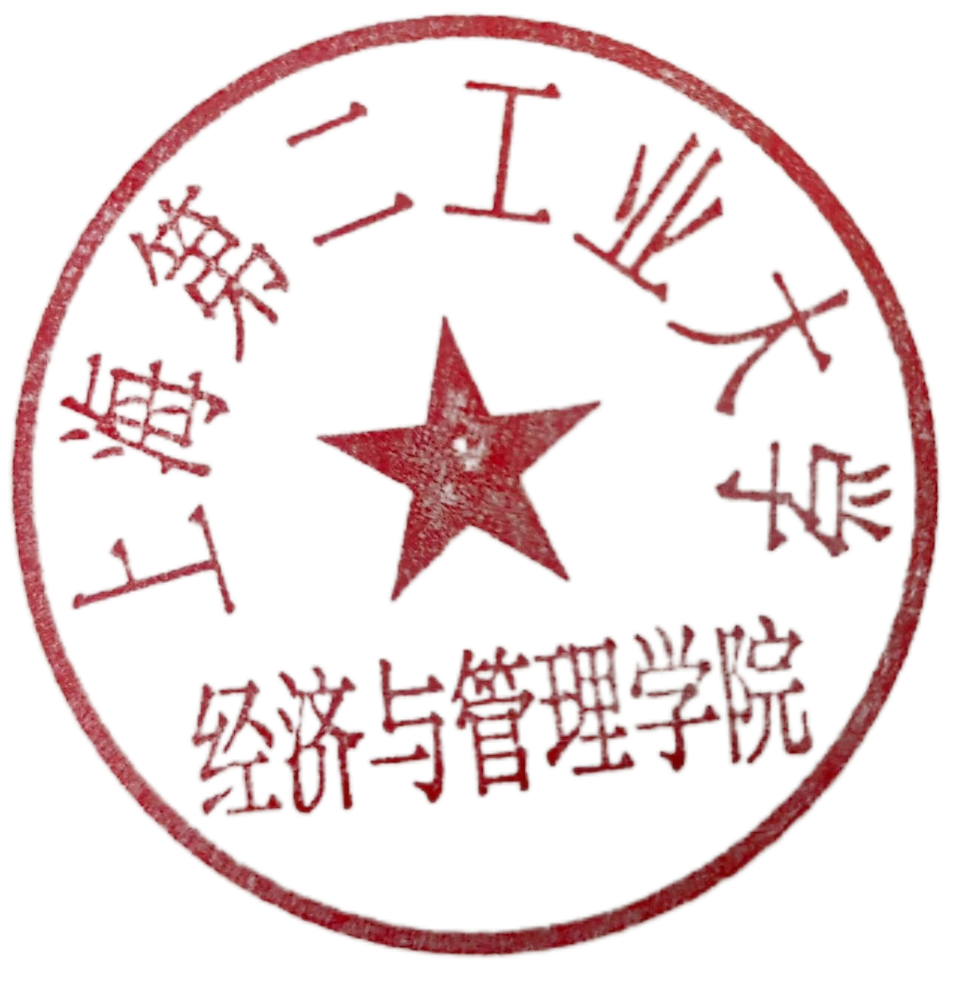因11号楼小高层宿舍楼栋整装，现滞留宿舍楼内所有物品须于2024年7月12日前清空。如因历史原因目前仍有未清理物品，请于2024年7月12日前自行或委托他人处理，逾期滞留物品将统一清空处理。

上海第二工业大学

经济与管理学院

2024年7月9日

Notice of Items Cleaning in Building 11（Xiao Gao Ceng）Accommodation

Due to the decoration of the Building 11（Xiao Gao Ceng）Accommodation, all the items and luggage kept in this accommodation building must be cleared by July 12, 2024. If there are still uncleared items due to historical reasons, please handle them by yourself or entrust others to deal with it before July 12, 2024, and the overdue items will be all emptied.

Shanghai Polytechnic University

School of Economics and Management

July 9, 2024